

**Department of Computer Science and Engineering**

**Lab Report-02**

**Course Title: Computer Graphics Laboratory**

**Course Code: CSE-304**

**Title: Implementation of mid point circle algorithm and Ellipse algorithm**

**Submitted by:**

Name: Nasrin Akter Shimu

Class roll: 2211

Date of submission: 04-06-2023

**Submitted to:**

|  |  |
| --- | --- |
| **Dr.Mohammad Shorif Uddin**  Professor  Department Of Computer Science And Engineering  Jahangirnagar University | **Dr. Morium Akter**  Associate Professor  Department Of Computer Science And Engineering  Jahangirnagar University |

**Mid point circle algorithm implement:**

Code:

|  |  |
| --- | --- |
| #include<iostream>  #include<graphics.h>  using namespace std;  void drawcircle(int xc,int yc,int x,int y)  {  putpixel(xc+x,yc+y,YELLOW);  putpixel(xc+x,yc-y,YELLOW);  putpixel(xc-x,yc+y,YELLOW);  putpixel(xc-x,yc-y,YELLOW);  putpixel(xc+y,yc+x,YELLOW);  putpixel(xc+y,yc-x,YELLOW);  putpixel(xc-y,yc+x,YELLOW);  putpixel(xc-y,yc-x,YELLOW);  }  int main()  { int xc,yc,r,x,y,p;  cout<<"Enter center coordinates (xc, yc) and radious(r): ";  cin>>xc>>yc>>r;  int gd=DETECT,gm;  initgraph(&gd,&gm,(char*)""); | setcolor(YELLOW);  x=0;y=r;  p=1-r;  while(x<=y)  {  drawcircle(xc,yc,x,y);  x++;  if(p<0)  {  p=p+(2*x)+1;  }  else  { y--;  p=p+2*(x-y)+1;  }  drawcircle(xc,yc,x,y);  }  getch();  closegraph();  return 0;  } |

**Input and Output:**

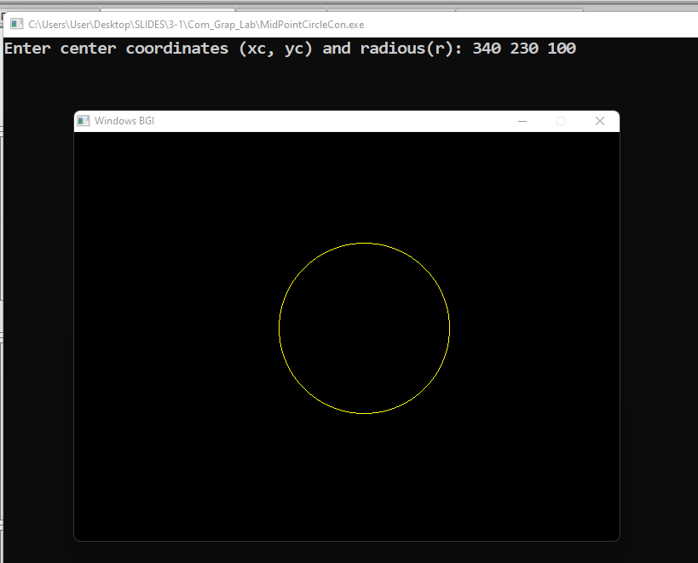

**Mid point Ellipse implement code:**

|  |  |
| --- | --- |
| #include<bits/stdc++.h>  #include<graphics.h>  using namespace std;  void drawellipse(int xc,int yc,int x,int y)  {  putpixel(xc+x,yc+y,YELLOW);  putpixel(xc+x,yc-y,YELLOW);  putpixel(xc-x,yc+y,YELLOW);  putpixel(xc-x,yc-y,YELLOW);  }  void midpointEllipse(int xc,int yc,int a,int b)  {  int x=0;  int y=b;  double d1=b*b-a*a*b+0.25*a*a;  int dx=2*b*b*x;  int dy=2*a*a*y;  while(dx<dy)  {  drawellipse(xc,yc,x,y);  if(d1<0)  {  x++;  dx=dx+2*b*b;  d1=d1+dx+b*b;  }  else  {  x++;  y--;  dx=dx+2*b*b; | dy=dy-2*a*a;  d1=d1+dx-dy+b*b;  }  }  double d2=b*b*(x+0.5)*(x+0.5)+a*a*(y-1)*(y-1)-a*a*b*b;  while(y>=0)  {  drawellipse(xc,yc,x,y);  if(d2>0)  {  y--;  dy=dy-2*a*a;  d2=d2+a*a-dy;  }  else{  y--;  x++;  dx=dx+2*b*b;  dy=dy-2*a*a;  d2=d2+dx-dy+a*a;  }  }  }  int main()  {  int xc,yc,a,b;  cout<<"Enter center coordinates,max axis ,min axis: ";  cin>>xc>>yc>>a>>b;  int gd=DETECT,gm;  initgraph(&gd,&gm,(char*)"");  setcolor(YELLOW);  midpointEllipse(xc,yc,a,b);  getch();  closegraph();  return 0;  } |

**Input and Output:**

